Spelling words- rules most frequently used in past papers.

Rather than learning lots of words, remembering certain rules can be just as helpful.

For example, dis- and mis- prefixes always have 1 s.

-ful suffixes always have 1 l

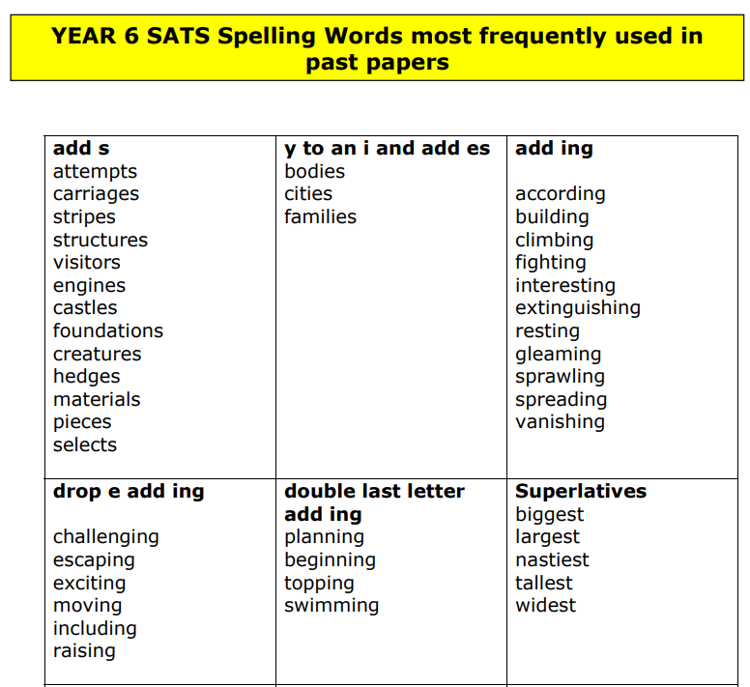

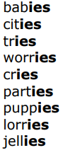

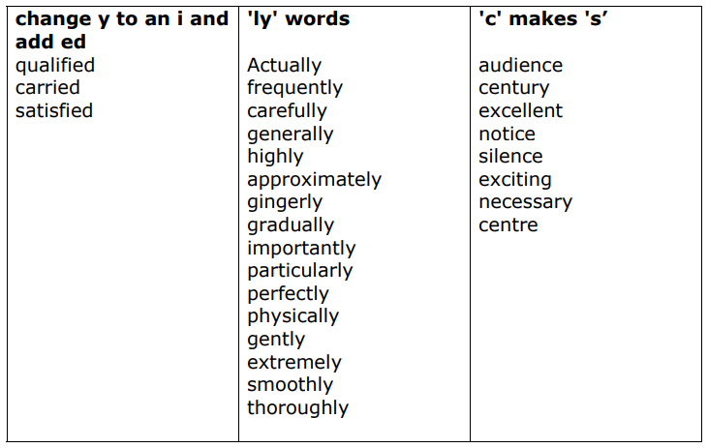

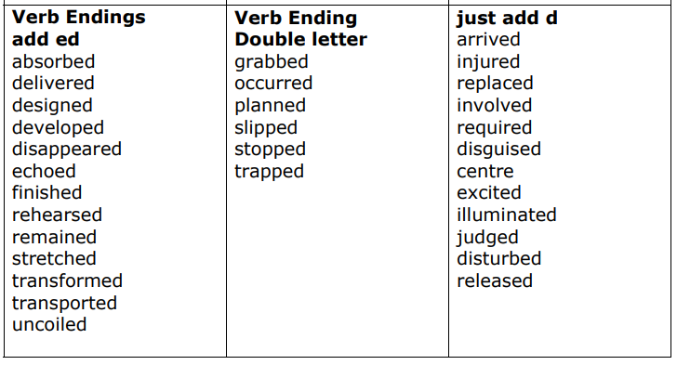

Children often forget the ‘e’ when added ed. Especially in words that have repetitive letters. E.G

Preferred, referred, remembered.

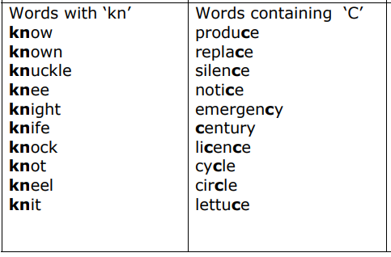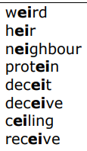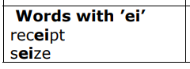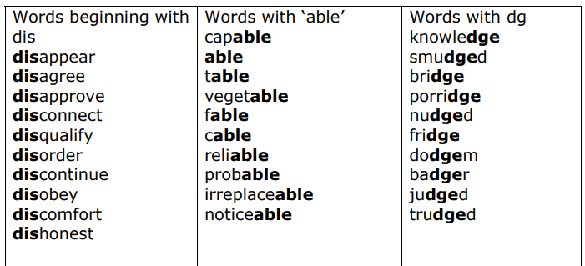

There will of course be other words that may feature in the test.

There are always words with silent letters for example.

There may also be words from the statutory word list.

Please don’t try and practice ALL the words!

Learning certain rules can be just as useful.

Remember- the spelling score goes with the grammar score so don’t worry if spelling isn’t an area of strength!

Words that end with –able usually have a root word. Words that end with –ible usually don’t have a root word (incredible, sensible)