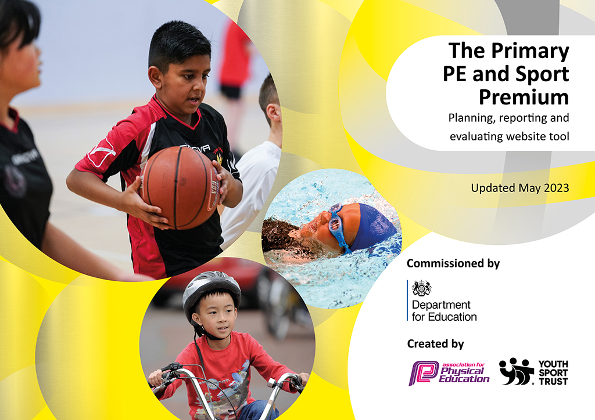
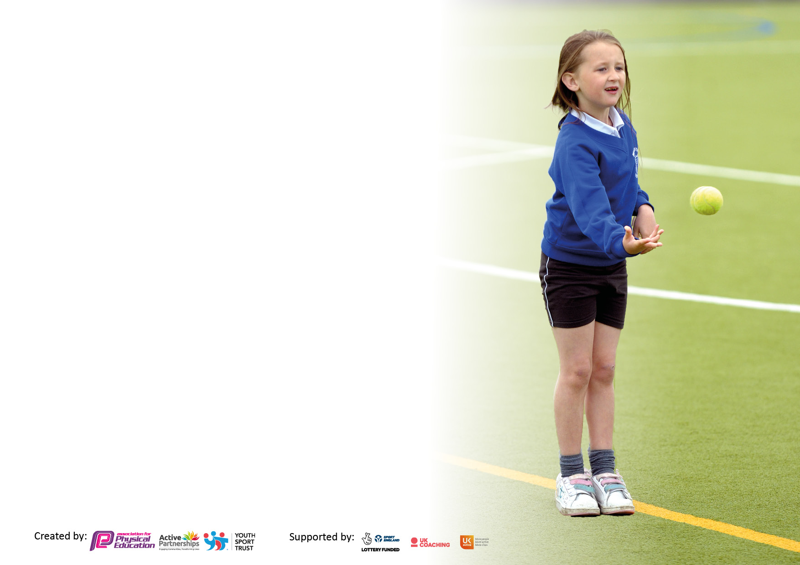

It is important that your grant is used effectively and based on school need. The Education Inspection Framework makes clear there will be a focus on ‘whether leaders and those responsible for governors all understand their respective roles and perform these in a way that enhances the effectiveness of the school’.

Under the Quality of Education Ofsted inspectors consider:
Intent - Curriculum design, coverage and appropriateness
Implementation - Curriculum delivery, Teaching (pedagogy) and Assessment
Impact - Attainment and progress

To assist schools with common transferable language this template has been developed to utilise the same three headings which should make your plans easily transferable between working documents.

Schools must use the funding to make additional and sustainable improvements to the quality of Physical Education, School Sport and Physical Activity (PESSPA) they offer. This means that you should use the Primary PE and sport premium to:

- Develop or add to the PESSPA activities that your school already offer
- Build capacity and capability within the school to ensure that improvements made now will benefit pupils joining the school in future years
- The Primary PE and sport premium should not be used to fund capital spend projects; the school’s budget should fund these.

Pleasevisitgov.ukfortherevisedDfEguidanceincludingthe5keyindicatorsacrosswhichschoolsshoulddemonstrate animprovement.Thisdocumentwillhelpyoutoreviewyourprovisionandtoreportyourspend.DfEencouragesschools to use this template as an effective way of meeting the reporting requirements of the Primary PE and Sport Premium.

We recommend you start by reflecting on the impact of current provision and reviewing the previous spend.

Schools are required to publish details of how they spend this funding, including any under-spend from 2021/2022, as well as on the impact it has on pupils’ PE and sport participation and attainment. All funding must be spent by 31st July 2023.

We recommend regularly updating the table and publishing it on your website throughout the year. This evidences your ongoing self-evaluation of how you are using the funding to secure maximum, sustainable impact. Final copy must be posted on your website by the end of the academic year and no later than the 31st July 2023. To see an example of how to complete the table please click HERE.

Details with regard to funding
Please complete the table below.

Total amount carried over from 2021/22 | £unknown
Total amount allocated for 2021/22 | £unknown
How much (if any) do you intend to carry over from this total fund into 2022/23? | £18,000
Total amount allocated for 2022/23 | £18,000
Total amount of funding for 2023/23. To be spent and reported on by 31st July 2023. | £18,000
Swimming Data
Please report on your Swimming Data below.

Meeting national curriculum requirements for swimming and water safety.

N.B. Complete this section to your best ability. For example you might have practised safe self-rescue techniques on dry land which you can then transfer to the pool when school swimming restarts.
Due to exceptional circumstances priority should be given to ensuring that pupils can perform safe self rescue even if they do not fully meet the first two requirements of the NC programme of study
What percentage of your current Year 6 cohort swim competently, confidently and proficiently over a distance of at least 25 metres?  N.B. Even though your pupils may swim in another year please report on their attainment on leaving primary school at the end of the summer term 2022.  Please see note above | 92%
What percentage of your current Year 6 cohort use a range of strokes effectively [for example, front crawl, backstroke and breaststroke]?  Please see note above | 88%
What percentage of your current Year 6 cohort perform safe self-rescue in different water-based situations? | 88%
Schools can choose to use the Primary PE and sport premium to provide additional provision for swimming but this must be for activity over and above the national curriculum requirements. Have you used it in this way? | Yes

Action Plan and Budget Tracking
Capture your intended annual spend against the 5 key indicators. Clarify the success criteria and evidence of impact that you intend to measure to evaluate for pupils today and for the future.

Academic Year: 2022/23 | Total fund allocated: | Date Updated:
Key indicator 1: The engagement of all pupils in regular physical activity – Chief Medical Officers guidelines recommend that primary school pupils undertake at least 30 minutes of physical activity a day in school |  |  |  | Percentage of total allocation:
 |  |  |  | %
Intent | Implementation |  | Impact
Your school focus should be clear what you want the pupils to know and be able to do and about  what they need to learn and to  consolidate through practice: | Make sure your actions to achieve are linked to your intentions: | Funding allocated: | Evidence of impact: what do pupils now know and what can they now do? What has changed?: | Sustainability and suggested next steps:
To maximise the engagement of all pupils in physical activity at lunchtime, during lesson time and after school. | Use Fortius and PE lead to assign a small group of Y5/Y6 children to be play leaders and help them lead games at lunch time and be in charge of ‘Craze of the Week.’ | £13,348 | Children have opportunities to be active every lunchtime. More is on offer for the children such as themed activities and more space to be active in. One teacher runs a football match for Y3/4/5 every lunchtime so it’s refereed and Y6 have their own space now which has caused fewer fallouts and more enjoyment.  The introduction of more resources which are for lunchtimes only have improved behaviour. | 79%
To close the gap in swimming standards, aiming for 100% of children to achieve the NC swimming standard with additional top up lessons in order to achieve this. | Arrange swimming lessons for KS2 children once a week and allow Y4, Y5 and Y6 children who cannot swim 25m additional sessions.  Money used to go towards coach costs for ‘top up’ sessions. | £1000  (allocated by previous Headteacher) | Children in KS2 are having regular opportunities to develop their swimming skills and children who need additional and extra can have that.  Children in KS2 can swim 25m before they leave primary school. | Organise timetable for swimmers so they go in year groups, not classes (mixed classes)
Key indicator 2: The profile of PESSPA being raised across the school as a tool for whole school improvement |  |  |  | Percentage of total allocation:
 |  |  |  | 0%
Intent | Implementation |  | Impact
Your school focus should be clear what you want the pupils to know and be able to do and about  what they need to learn and to  consolidate through practice: | Make sure your actions to achieve are linked to your intentions: | Funding allocated: | Evidence of impact: what do pupils now know and what can they now do? What has changed?: | Sustainability and suggested next steps:
To raise the profile of sport and increase the amount of sporting and competitive opportunities for the children. | To make more links with the surrounding schools, to build relationships with Fortius (new Head, new PE lead), Wiltshire Cricket, Grassroots etc  New PE lead to enter more competitions at the start of the year and put the date in the school diary, planning ahead. | £13,348 (Fortius PE package)  This includes the competitions we choose to enter. | The impact has been huge this year. Parent voice from last year requested more sporting opportunities for the pupils and parents have been thrilled with the increased opportunities for children to be competitive and represent their school in fixtures. Children from Y1-Y6 have had opportunities to participate in Dance, athletics, cross country, football, tag-rugby, dodgeball, hard ball cricket, | Retain and build relationships with these providers and other schools to arrange more fixtures in 2023-24.
To raise the awareness and build excitement of sport to the school community through more advertising, promoting and celebration of sport | Celebrate the sporting achievements of the children by showing photos on our new Instagram page, in our school newsletter, on our school website and on displays in school. | £0 | Sport is celebrated in our newsletter, assemblies, on Instagram and on our website.  There is a PE board in our school showing photographs of our pupils. | Very sustainable and will continue next year.

Key indicator 3: Increased confidence, knowledge and skills of all staff in teaching PE and sport |  |  |  | Percentage of total allocation:
 |  |  |  | 21%
Intent | Implementation |  | Impact
Your school focus should be clear | Make sure your actions to | Funding | Evidence of impact: what do | Sustainability and suggested
what you want the pupils to know | achieve are linked to your | allocated: | pupils now know and what | next steps:
and be able to do and about | intentions: |  | can they now do? What has
what they need to learn and to |  |  | changed?:
consolidate through practice:
Use of Fortius PE to upskill new teachers, including x2 ECTs every week in PE lessons with every class. | Use of Fortius PE to work alongside staff and up skill them in particular areas | Included in Fortius PE costs |  | Next year, teachers will no longer have this CPD and Fortius will be used to teach during teachers’ PPA time. Teaching of Real PE and sports that link to each ‘cog’ will alternate between Fortius coaches and class teachers.
X2 new Forest school leaders trained (existing HLTAs) | Level 3 training 2022-23 | £995x2 Level 3 training  £500 Equipment  TOTAL FS  £3151.20 | All children have received 2 terms (1 large term) of Forest School with 2 qualified leaders who adapt their sessions to meet the age and needs of each class.  Children have enjoyed outdoor learning and benefitted from the skills they’ve learnt. Children have had 12 weeks of outdoor learning. | Teachers to accompany Forest School leader next year to gain CPD.  Money will be saved on courses for forest school leaders.
Use of Real PE | Every class uses Real PE to teach the fundamental skills such as sportsmanship, celebrating wins and losses, personal targets etc | £695 | PE lessons have a consistency across the school and teachers are more confident teaching PE using the scheme. | Continue to use Real PE. PE lead to plan the cogs for the year and which sports link nicely to the fundamentals.
Key indicator 4: Broader experience of a range of sports and activities offered to all pupils |  |  |  | Percentage of total allocation:
 |  |  |  | 0%
Intent | Implementation |  | Impact
Your school focus should be clear | Make sure your actions to | Funding | Evidence of impact: what do | Sustainability and suggested
what you want the pupils to know | achieve are linked to your | allocated: | pupils now know and what | next steps:
and be able to do and about | intentions: |  | can they now do? What has
what they need to learn and to |  |  | changed?:
consolidate through practice:
Provide all children with more opportunities to play sport.  To provide children with a varied menu of ASCs and PE lessons.  Continue to offer varied forest school sessions to every class. | More ‘taster sessions’ for every class which lead to interest in joining their after school club.  All children to receive bespoke and differentiated forest school sessions for 12 weeks. | £0  Taster sessions are free. | Taster sessions and ASC have included cricket, cheerleading, fencing, drama.  Children are receiving forest school session and gaining skills. | Continue listening to pupil/ parent voice around what ASC they’d like and offering varied clubs.  Children will receive 6 forest school sessions over the year. Teachers to gain CPD and will also attend sessions.

Key indicator 5: Increased participation in competitive sport |  |  |  | Percentage of total allocation:
 |  |  |  | 0%
Intent | Implementation |  | Impact
Your school focus should be clear | Make sure your actions to | Funding | Evidence of impact: what do | Sustainability and suggested
what you want the pupils to know | achieve are linked to your | allocated: | pupils now know and what | next steps:
and be able to do and about | intentions: |  | can they now do? What has
what they need to learn and to |  |  | changed?:
consolidate through practice:
All children be given the opportunity to take part in competitions both in school and against other schools.  More opportunities and competitions for children across the school.  Sport and ‘grit’ power is celebrated and recognized. | New PE lead to form more relationships with Fortius, Wiltshire sport, other schools and outside agencies so more sport and PE can be played.  More after school clubs. | £0 Fortius payment covers their ASC one day a week and all competitions we choose to enter.  Parents have taken children to events so no coach needed.  Parents pay for after school clubs. | Parent voice has been overwhelmingly positive due to increased opportunities for children to play more competitive sports against other schools.  Children from Y1-Y6 have all had opportunities to be involved in: dance festivals, athletics, cross-country, dodgeball, tag-rugby, football, hard ball cricket, dynamo cricket.  Taster sessions and ASC have included cricket, cheerleading, fencing, drama. | Very sustainable. Will continue to enter multiple tournaments and fixtures next year.  Next steps: perhaps liaising with local schools to arrange friendlies in football, tag-rugby or cricket (most popular).

Signed off by
Head Teacher: | Becca Hine
Date: | 24.07.23
Subject Leader: | Rachel Harris
Date: | 03.06.23
Governor:
Date:

