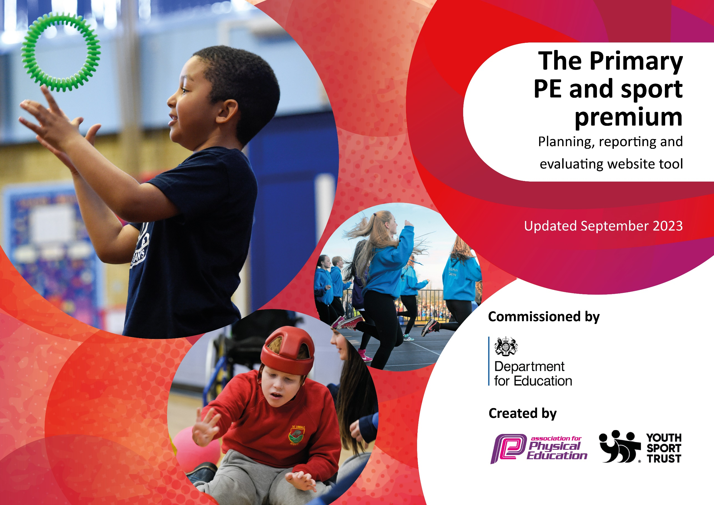

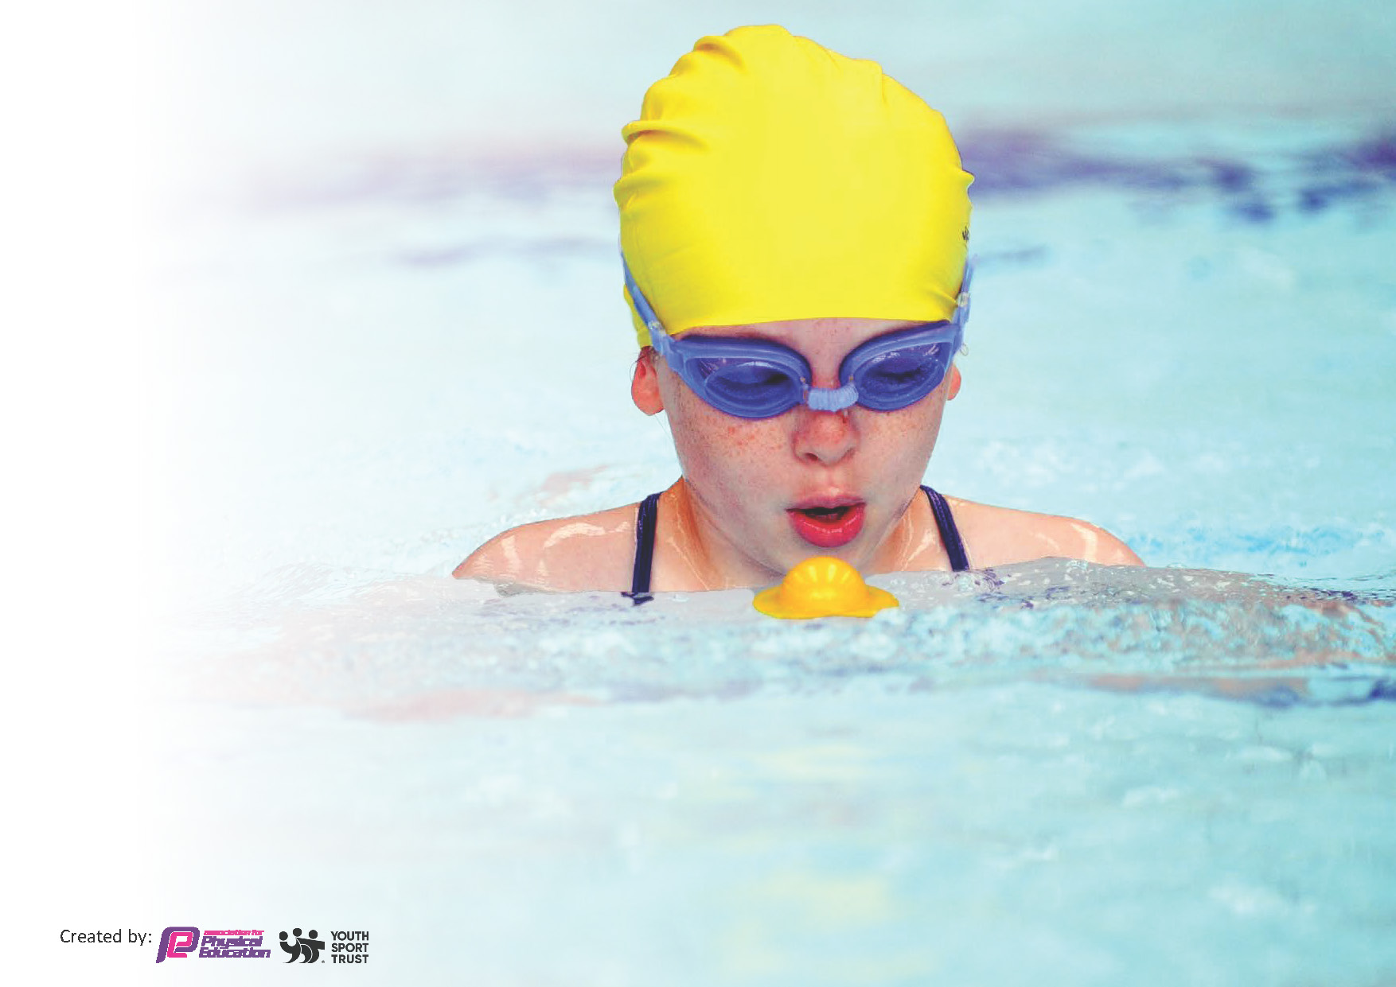
This template can be used for multiple purposes:
by:
- It enables schools to effectively plan their use of the Primary PE and sport premium
- It helps schools to meet the requirements (as set out in guidance) to publish information on their Primary PE and sport premium
- It will be an effective document to support Ofsted inspections enabling schools to evidence progress in Physical Education (PE) and evidence swimming attainment, which forms part of the PE National Curriculum. We would recommend schools consider
the Intent, Implementation and Impact of any spend, as examined within the Education Inspection Framework.

It is important that your grant is used effectively and based on school need.

Schools must use the funding to make additional and sustainable
improvements to the quality of the PE, School Sport and Physical Activity (PESSPA)
they offer. This means that you should use the Primary PE and sport premium to:

- Build capacity and capability within the school to ensure that improvements made now will benefit pupils joining the school in future years
- Develop or add to the PESSPA activities that your school already offers.

The Primary PE and sport premium should not be used to fund capital spend projects; the school’s core budget should fund these. Further detail on capital expenditure can be found in the updated Primary PE and sport premium guidance.

The Primary PE and sport premium guidance, outlines 5 key priorities that funding should be used towards. It is not

necessary that spending has to meet all the key priorities, you should select the priorities that you aim to use any funding towards.

Although completing this template is not a requirement for schools, schools are required to publish details of how they spend this funding. Schools must also outline what the impact this funding has had on pupils’ PE and sport participation and attainment and how any spending will be sustainable in the future. All funding must be spent by 31st July 2024.

The Department for Education has worked closely with the Association for Physical Education (afPE) and the Youth Sport Trust (YST) to develop this template and encourages schools to use it. This template is an effective way of meeting the reporting requirements of the Primary PE and sport premium.
Review of last year’s spend and key achievements (2022/2023)

We recommend you start by reflecting on the impact of current provision and reviewing your previous spend.

Activity/Action | Impact | Comments
To maximise the engagement of all pupils in physical activity at lunchtime, during lesson time and after school.  We have spent £11,457 on Fortius sports coaching and this includes entry into many sporting events all year round and after school clubs which are run by Fortius coaches (2x a week).  More equipment used to enhance PE lessons and Sports Day. Cost £1,075.  To raise the profile of sport and increase the amount of sporting and competitive opportunities for the children.  Spent money on Forest School equipment to enhance our Forest School sessions. Cost £354. | ‘Craze of the week’ at lunchtimes has seen more engagement with physical activity during lunchtimes.  We have ordered more things for children to play with at lunchtimes.  Fortius have taught PE lessons to all pupils and will continue to do so next year.  After school clubs have been running all year round and there has been a wide range of options available to all ages.  Better PE lessons.  We have tried to build on the competitive and non-competitive sporting opportunities available to our children. There have been many events made available for our pupils where they can compete and join in non-competitively.  Forest school sessions have been better and children have been able to be more involved. | Fortius have also run a session every Thursday for a group of children who we felt would benefit from sport mentoring.  Parents have supported our sporting fixtures by providing transport. Parents are pleased there are lots of opportunities for children to take part and represent the school.

Key priorities and Planning
This planning template will allow schools to accurately plan their spending.

Action – what are you planning to do | Who does this action impact? | Key indicator to meet | Impacts and how sustainability will be achieved? | Cost linked to the action
Build upon the lunchtime provision we have put in place this year. Train new lunchtime staff on ‘craze of the week’ and ask Y6 children to be more involved in running activities at lunchtime.  Employ Fortius coaching for 1.5 days. All classes will be taught PE once a week by a Fortius coach.  Allow children in Y3 and Y4 to have 10 swimming lessons. Provide additional swimming lessons for children in Y5 and Y6 who cannot swim 25m.  First aid course for 4/5 staff members to ensure more teachers are first aid trained for sporting events, school trips and residential camps.  Bikeability sessions for Y6 pupils to enable them to be road safe when cycling. | Lunch time supervisors, some Y6 pupils, SLT who are out at lunchtimes and any children who want to take part in the activity.  All children in our school.  Children in KS2.  Benefit all children and adults in our school when not on school grounds.  Y6 pupils. | Key indicator 2- Increase engagement of all pupils in regular physical activity and sport  Key indicator 4- Broader and more equal experience of a range of sports and physical activities offered to all pupils  Key indicator 2. Increase engagement of all pupils in regular physical activity and sport  Key indicator 3. The profile of PE and sport is raised across the school as a tool for whole school improvement  Key indicator 4. Broader and more equal experience of a range of sports and physical activities offered to all pupils  Key indicator 4. Broader and more equal experience of a range of sports and physical activities offered to all pupils  Key indicator 1- Increase confidence, knowledge and skills of all staff in teaching PE and sport  Key indicator 4. Broader and more equal experience of a range of sports and physical activities offered to all pupils  Key indicator 2. Increase engagement of all pupils in regular physical activity and sport | More pupils meeting their daily physical activity goal, more pupils encouraged to take part in PE and Sport Activities.  Can be sustained over time through regular timetabling of activities, the same staff being outside at lunchtimes, Y6 being trained to lead activities.  All children will be taught once a week by a sports coach. High quality PE lessons will be taught to all.  There will also be 2 sports clubs run every week for children to participate in.  Children in KS2 have an opportunity to develop their swimming skills and be able to swim 25m to meet national expectations.  More first aid trained staff.  More flexibility of who can attend off site events.  More confident members of staff.  Children will be taught how to be safe when riding near roads. | Possibly around £250 for equipment across the whole year.  £11,457 for Fortius coaches to come into our school 1.5 days a week plus 2 after school clubs.  £2755 (expected cost)  £500 (approximately. Exact pricing TBC)  £118 (expected)

Key achievements 2023-2024
This template will be completed at the end of the academic year and will showcase the key achievements schools have made with their Primary PE and sport premium spending.

Activity/Action | Impact | Comments
We have achieved the silver award in the sports games mark. This is an improvement from bronze the year before.  No cost.  Bikeability was a success and every Y6 child who participated passed.  Cost: £118.  We have entered many different sporting fixtures and competitions this year. These include: football matches and tournaments, cricket matches and tournaments, athletics, tag-rugby tournaments, dodgeball.  There have been requests for gymnastics to be something we offer next year. | Lots of sporting opportunities for our children and lots of pupils in our school are being active every day while in school. There is an enjoyment of PE and sport at our school. Teachers have received CPD from watching sports coaches lead PE sessions and we have had lots of ‘taster days’ where children have trialed more sports which they can then try again in an after school club.  21 of our 26 Y6 children are now safe to cycle on the roads.  Many children have had the opportunity to compete and represent our school.  We have kept records of who has competed so we can make it as fair as we can when there are many children who want to participate in the same event. | Our next steps are to communicate with parents about why certain children have been selected for chosen events and what the desired outcome is (to win/ to provide opportunities for LED/SEN/PP children/ to learn a new skill etc)  Staff at Sutton Benger have made a real effort to ensure we enter as many events as possible so many pupils can compete and enjoy sport. Parents are brilliant at helping with transport.

Swimming Data
Meeting National Curriculum requirements for swimming and water safety.
Priority should always be given to ensuring that pupils can perform safe self-rescue even if they do not fully meet the first two requirements of the National Curriculum programme of study

Question | Stats: | Further context  Relative to local challenges
What percentage of your current Year 6 cohort can swim competently, confidently and proficiently over a distance of at least 25 metres? | 80% | Two children arrived late to our school and chose not to attend further swimming lessons with younger year groups.  Two children can pretty much swim 25m but lack confidence and enjoyment and didn’t want to continue lessons.
What percentage of your current Year 6 cohort can use a range of strokes effectively [for example, front crawl, backstroke, and breaststroke]? | 96% | All have had lessons where different strokes have been taught. Many children have lessons outside of school time.

What percentage of your current Year 6 cohort are able to perform safe self-rescue in different water-based situations? | N/A% | Despite many conversations with the swimming instructors at the local pool, this was not taught to our Y6s.  I have requested this is done next year.
If your schools swimming data is below national expectation, you can choose to use the Primary PE and sport premium to provide additional top-up sessions for those pupils that did not meet National Curriculum  requirements after the completion of core lessons. Have you done this? | Yes
Have you provided CPD to improve the knowledge and confidence of staff to be able to teach swimming and water safety? | No | Teachers and other staff members attend swimming lessons but lessons are led by swimming instructors.

Signed off by:

Head Teacher: | Becca Hine
Subject Leader or the individual responsible for the Primary PE and sport premium: | Rachel Harris
Governor: | Tony Weedon
Date: | 30.07.24

