Handwriting

A key focus for Beech Class this year is to improve our handwriting. This will help with our work in all areas of the curriculum.

We will be working on this in class but in order to get even more time spent practicing, the majority of homework being set this term will be to improve handwriting. Below are some handwriting tips and tricks to help.

Seating position
Are you sitting comfortably? Ideally, your chair and table should be the correct height for you. You should be able to place your feet on the floor and the table should be at about elbow height. This makes a big difference to your handwriting. Have you tried writing on the floor while sitting on your knees? It's very awkward and hard to write neatly. So try and find somewhere you can writing that is perfect for you.

Sitting on the line
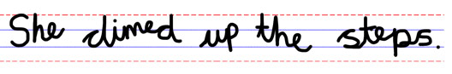
Sit your letters on the line for neater handwriting. Don't let the letters fly off the line like balloons.

Making the letters the same size
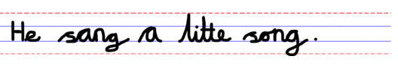
Are all your small letters the same size? Draw a line along the top of the small letters to see if they are. If you are having problems keeping your letters the same size then try writing on ruled paper with guidelines for a while until you become an expert at this.

Spacing
Letters and words should be evenly spaced. Letters in words should not have any big gaps or they could look like separate words.

Leave enough space for a letter o between your words. See how many o's you can place in between your words. You only need to fit one in. So if can add lots of o's then make your gaps smaller.
If you more practice with this place lolly stick after your words so you can see where to write the next one.

Slanting
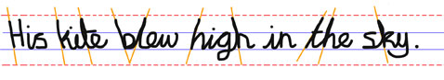
If your writing is slanted make sure it is always slanted in the same direction. Having your letter leaning different ways can make your writing harder to read. Having your paper slight it turned when you are writing may help you keep all the letters leaning the same way.

Joined up writing
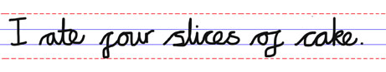
Use joined-up writing. It will make your writing faster because you don't have to lift your pen so often and it looks neater.

